Конспект урока английского языка на тему
«Современные технологии. Мобильные телефоны»

Учитель: Пысь А В
Класс: 9
Тема раздела: Modern Technologies
Тема урока: “Mobile Phones”
Тип урока:
Урок комплексного применения знаний с использованием электронно-образовательных ресурсов.
Цель урока: совершенствование навыков чтения, аудирования и говорения по теме «Современные технологии в нашей жизни».
Задачи:
Предметные:
- обогатить и закрепить лексический запас учащихся по теме «Современные технологии в нашей жизни»;
- Совершенствовать навыки аудирования с выделением выборочной информации
- развивать навыки говорения в ролевых диалогах и обсуждениях, переносить лексический материал в ситуацию речевого общения.
Метапредметные:
• Коммуникативные:
– развивать навыки переработки информации (анализ прочитанной информации), перевод визуального ряда в речевой (умение оформлять свои мысли в устной форме и понимать речь других);
– формировать коммуникативные компетенции учащихся через парную и групповую работу.
• Регулятивные:
– развивать навыки определения целей работы;
- закрепить умение контролировать и оценивать результаты своей деятельности;
- развивать речевые и языковые способности, память, внимание, восприятие и воображение.
• Познавательные:
- устанавливать смысловые соответствия при восприятии речи на слух;
- закрепить умения классифицировать, обобщать;
- строить логическое рассуждение, включающее установление причинно-следственных связей;
- осуществлять анализ информации.
Личностные:
- формировать способность оценивать усваиваемое содержание (исходя из социальных и личностных ценностей), обеспечивающую личностный моральный выбор при использовании новых технологий;
- воспитывать чувство ответственности за совместную групповую работу;
- формировать положительную мотивацию к обучению, к совершенствованию своих знаний;
- воспитывать уважения к точке зрения собеседника.
Ход урока
- Мотивирование к учебной деятельности

- Teacher: Good morning, pupils! I am glad to see you. How are you? Let’s start our lesson. Today we are going to continue our conversation about modern technologies. What modern device will we discuss today? Listen to my clues and try to guess what item I'm describing. (1 min.)
- Almost everyone has one these days.
- I am usually in your pocket or your bag.
- You can use me to do many different things.
- I can connect you to other people.
- I can make phone calls.

You are right, we are going to speak about MOBILE PHONES today and see how new technologies influence our life and language.

- Brainstorming.
Teacher: Think about how you use your mobile phone. Try to name as many ways to use this gadget as possible.
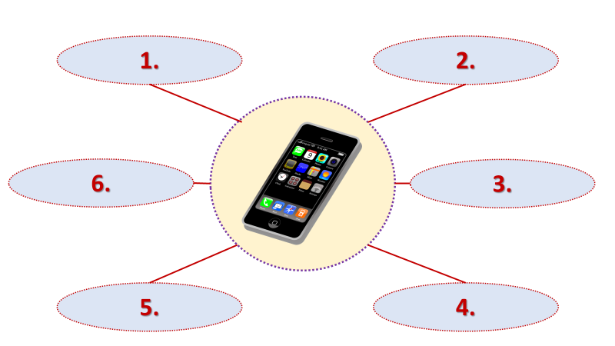
- Ranking

Teacher: Add two more uses to the table. Than rank each use from 1 (the most frequent) to 7 (the least frequent). When you have completed your table, compare your answers with a partner. Ask for more information. Which is the most common use of mobile phones? Are you surprised by the result?
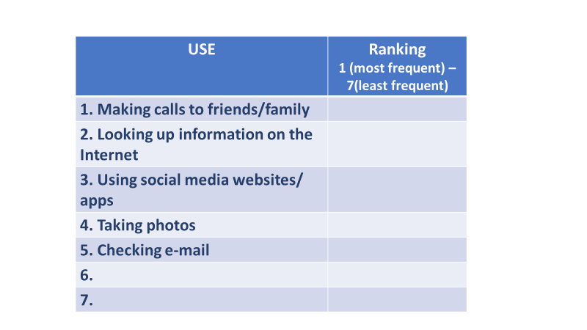
- Vocabulary revision.
a) Now I’d like to ask you how many words you know connected to phones and making calls. The first task is to match the beginning of the phrase from column A to the end from column B. What are these phrases in your language?
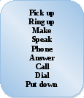
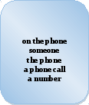
A B

Answers: Pick up the phone, ring someone up, make a phone call, speak on the phone, phone someone, answer the phone, call on the phone, dial a number, put down the phone.
b) What other words connected to mobile phones do you know?
Bring in a mobile if you have one or draw one on the board. To elicit the verbs use mime. Try to cover the following:
• touch screen
• keys / buttons
• power button
• home button
• to switch on/off
• to dial
• to hang up
• to text
• ring tone
• charger
• apps / applications
• Bluetooth

Add any more you think appropriate for the level. If any of them are new, write them up on the board and give students time to work in pairs and mime to each other to familiarise themselves with the new words. Discuss the questions as a group.

Quiz
c) And here is a QUIZ: ‘How much do you know about telephoning?’ Look at the blackboard, read the questions and choose the answer.
1. Who invented the telephone? (Alexander Bell)
2. Which language does the word ‘telephone’ come from? (Greek = sound from a
long distance).
3. Fill in the gap: ‘I’m afraid you’ve got the __________ number.’ (wrong)
4. Which phrasal verb means ‘wait’? (hold on)
5. When you pick up the phone you need to __________ the number. (dial)
6. Do you make or do a phone call? (make)
7. Fill in the gap: ‘One moment, I’ll put you ___________ to him.’ (through)
8. SMS = __________ ___________ ___________ (Short Messaging System).
9. What is the American English word for ‘mobile’? (cell phone/cellular phone).
10. How many phone numbers could the first mobile phones hold in their memory? (30)
11. What were the first words spoken on a mobile? (‘’Guess where I’m calling from?’’)
12. What is the universal emergency number for all mobile phones in the EU? (112)

- Listening

Teacher: Watch the video about the history of the telephone and answer the questions from worksheet A (Приложение 1)
https://www.youtube.com/watch?v=qWUP9EigdjY
1. What device does the presenter use to demonstrate how the telephone works?
2. What are the examples of some new phrases that entered the English language?
3. Why didn't people want to have the first telephones on display?
4. Why operator girls weren't a perfect solution?
5. What are microwaves?
6. What happened in the 1980s?
7. Who were the owners of the first mobile phones?

Answers:
1. The presenter uses 'a cup and string telephone'.
2.They are 'ring off' (вешать трубку) and 'She's hung up on me' (Она бросила
трубку).
3. The first telephones were considered very ugly.
4. At 8.00 p.m. operator girls stopped working as they were not allowed to work night
shifts. Besides, if they got married they had to give the job up.
5. They are high frequency radio waves.
6. In the 1980s a phone system began to go digital and the whole cabling system was replaced by optical fiber. The first mobile phones appeared.
7. The owners of the first mobile phones mostly were businessmen.

- Reading

Teacher: A radio station recently asked its listeners for their points of view about mobile phones. This is what some of them said. As you read the dialogues think about the following:
• Do you agree with anything the people say?
• Do you know anyone with similar views to these people?
• What would you reply to this person if you were the radio presenter?
Paula from Newcastle
‘’I couldn’t live without my mobile phone. I think I’m addicted to it in fact! I make over twenty calls a day and send at least forty text messages. I just like to be in touch with all my friends. It used to be more expensive to send texts but I’ve got a special deal with the phone company now so all texts are free and calls are cheaper too. Anyway – I wouldn’t give it up for all the money in the world!’’

Maria from Cardiff
‘’I have a mobile but I try not to use it too much. When I do have to use it for a long time I worry about what’s happening to my brain. Sometimes my ear gets really hot and I get a headache – I’m sure it’s not good for you. We all use them but there hasn’t been much research into the dangers. Another thing that worries me is people driving while they’re talking on their mobiles. Surely that causes road accidents. I’ve
even seen cyclists using mobiles – that’s just so dangerous!’’

Mahesh from London
‘’I think they’re really useful. It’s great to be able to call or text a mate and tell you’ll be a bit late to meet him. The other day my car broke down on the motorway and it was great to be able to phone for help. I got lost on the way to a friend’s house the other day and I just looked up the directions on my maps app. That was really handy.’’

Simon from Plymouth
‘’I’ve never had a mobile phone. I work from home, I’m a writer, so I really don’t need one. My girlfriend keeps trying to convince me to get one, but I won’t. She’s got an i-phone and raves about the fantastic apps and touch screen. She wants to get me one for my birthday, but I’d rather have a new laptop, actually. People think I’m a bit strange not having a mobile but I don’t want people to be able to know where I am and what I’m doing every minute of the day. I like to be un-contactable!’’

Anna from London
‘’I have a mobile but I’m really careful about switching it off when I’m in public places. I hate having to listen to other people’s conversations on the train and on the bus. I try not to listen but it’s impossible when people speak loudly. Often they have really personal conversations and I just don’t want to know their private business. It can be embarrassing. I think they should be banned in restaurants, art galleries and on public transport. The whole mobile phone culture is out of control and we shouldn’t accept it. It’s noise pollution!’’

Josh from Dublin
‘’I’m a teacher in a secondary school and mobile phones really annoy me. The students send messages to each other in the class and last month I caught some students cheating in an exam by sending messages to each other. Some students even bully others via texts these days – that’s really sad. In theory they are not allowed to bring them to school, but it’s nearly impossible to stop them. I don’t think parents shouldn’t buy them for their children. It’s crazy to see eleven-year-olds with their own mobiles. It must cost a fortune for their parents too.’’

Clare from Bristol
‘’I used to love my mobile phone – it had a great camera and some cool photo apps and I would upload loads of pictures of what I was doing to the internet. But it got out of hand – and I started to get really annoyed when I was out with friends and everyone was spending more time looking at their mobile phones than actually talking to each other. It just seemed ridiculous! So now, I have changed my smart phone for a basic mobile phone, just to make calls and send a few messages. I feel much better now that I am not so addicted to being on my mobile, and actually have real conversations with my friends.’’

- Discussion

- Put students into 4 groups.
- Cut up the discussion questions from Worksheet D (Приложение 4) into strips, and ask students to take it in turns to pick a card and ask the rest of the group their question to work it through.
- Encourage students to give reasons for their answers and opinions. Monitor and make a note of any good language or errors.
- At the end of the discussion, hold a brief feedback session so that students can share their ideas.

- Do you think your communication with friends and family would improve or get worse if you didn’t have a mobile phone? Why?
- People say that teenagers use their mobiles more than adults. Why do you think
this is?
- Are there any situations when you turn off your mobile phone? Why (not?)
- Why do you think so many people these days are addicted to their phones? Are
you addicted to your mobile? What advice would you give to someone who is
addicted to their phone?

Teacher: Now imagine that you are going to phone into the radio programme. What would you say? Write your comment below and then share it with your classmates. (This task can be offered to students as a home task after the first lesson on the topic “Mobile Phones”)

- Dialogue building
Prior to the lesson, cut up the dialogue from Worksheet B (Приложение 2). Cut up enough sets so that there is one set per pair of students.
• When the students have their completed dialogues in front of them, write on the
board or dictate the following questions:
• Then ask students to practice reading the dialogue out loud.
Teacher:
1) Please read the strips of paper and then try and put them in the correct
order. You can check your answers with other pairs, before correcting with the
whole class.
2) Now answer the questions:
1. What is the relationship between the two people? How do you know?
2. What is the main reason for the call?
3. What is Sophie going to do after the call?
3) Now practice reading the dialogue out loud. (First drill any difficult
words to focus on pronunciation, and you could drill whole sentences to focus on
intonation.)

- Writing text messages
Teacher: Now you are going to have some practice in writing text messages. But as text and instant messaging becomes more popular, language is changing. First, look at the blackboard and say if you use similar abbreviations in your own language.
What do you think the following abbreviations mean in these text messages?

1) CU L8R (See you later)
2) OMG UR so funny! (Oh My God! You are so funny!)
3) LOL (Laugh Out Loud / Lots Of Love)
4) THX 4 that (Thanks For That)
5) CU 2nite (See You Tonight)

Do you know any other abbreviations in English?
Now write a message for each of the situations in the role-play. Then swap your message with a partner and write a reply.

- Discussion

- Ask students to work through the following questions:

- Have messaging apps changed the way you communicate with your friends?
- What are the advantages of sending a message over making a phone call? Are
there any disadvantages?
- Some people think that writing online is making young people’s spelling and grammar worse. Do you agree? Why / not?
- Is it always a good idea to take a photo to remember an event or a place? Why (not)?
- Do you think mobile phones in the future will be smaller or bigger? Why?
What will you be able to do with your phone?

- Home task

Ask students to work through the rest of questions from the list at home.

- Summing-up
Teacher: Our lesson is over. Thanks for your good work! I believe this lesson was useful and interesting for you, and I think you are sure to make your life easier and more comfortable with the help of different modern technologies. Good luck!

Приложение 1.
Worksheet A

1. What device does the presenter use to demonstrate how the telephone works?
2. What are the examples of some new phrases that entered the English language?
3. Why didn't people want to have the first telephones on display?
4. Why operator girls weren't a perfect solution?
5. What are microwaves?
6. What happened in the 1980s?
7. Who were the owners of the first mobile phones?

Приложение 2
Worksheet B
‘’Hello’’

“’Hi Sophie, it’s Justin’’

‘’How are you?’’

‘’Fine thanks. Listen, I haven’t got long because I’ve got a maths class in a minute.

I just wanted to see if you’re still coming tonight.’’

“I’m not sure. I think my mum wants me to stay in tonight. I’ve got a Physics exam this week and I didn’t get a good mark in the last one’’

‘When is the exam?’’

‘’Not until Wednesday’’

‘’Well, what about if you come early and then my dad could give you a lift home at about ten. Most people are coming around seven anyway, and it would be cool if you came.’’
‘’OK, well, let me speak to my mum and I’ll message you later’’

‘’OK, cool.’’

‘’Chat later,’’

‘’Yeah, bye.’’

Приложение 3
Worksheet C: Role-Play situation cards

You need to cancel a trip to the cinema because you grandmother is coming for dinner.

Arrange with a good friend to go shopping on Saturday at the shopping center.

You phone your best friend on the morning of his / her birthday – you want to know what his / her plans are for the day.

Phone your parents to ask them if you can stay late after school for an extra drama class.

Tell your friend that you’re going to be late meeting them because of a train strike.

Phone your friend to find out where they are. You’ve been waiting for them in a café for 20 minutes.

Приложение 4
Worksheet D– Discussion questions
- Have messaging apps changed the way you communicate with your friends?
- What are the advantages of sending a message over making a phone call? Are there any disadvantages?
- Some people think that writing online is making young people’s spelling and grammar worse. Do you agree? Why / not?
- Is it always a good idea to take a photo to remember an event or a place? Why (not)?
- Do you think your communication with friends and family would improve or get worse if you didn’t have a mobile phone? Why?
- People say that teenagers use their mobiles more than adults. Why do you think this is?
- Are there any situations when you turn off your mobile phone? Why (not?)
- Why do you think so many people these days are addicted to their phones? Are you addicted to your mobile? What advice would you give to someone who is addicted to their phone?
- Do you think mobile phones in the future will be smaller or bigger? Why? What will you be able to do with your phone?

